  - 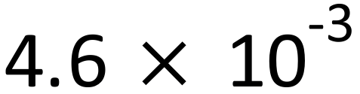
  - 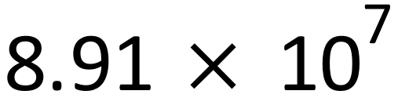

  - 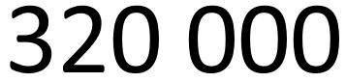
  - 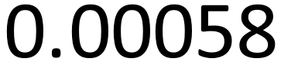

- 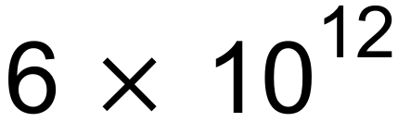
- 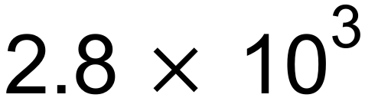
- 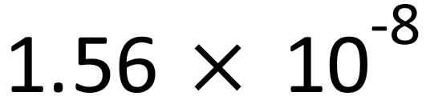
- 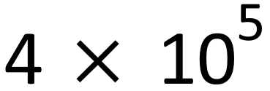

- 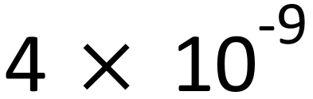
- 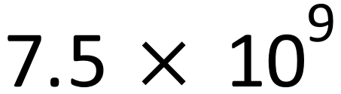
- 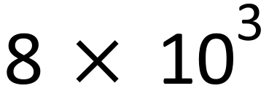
- 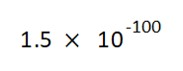

  - $3.3×{10}^{24}$ $m^{2}$
  - $2.6×{10}^{12}$ m

